**User Manual**

**508: Loop Detected ec500 i/o expander**

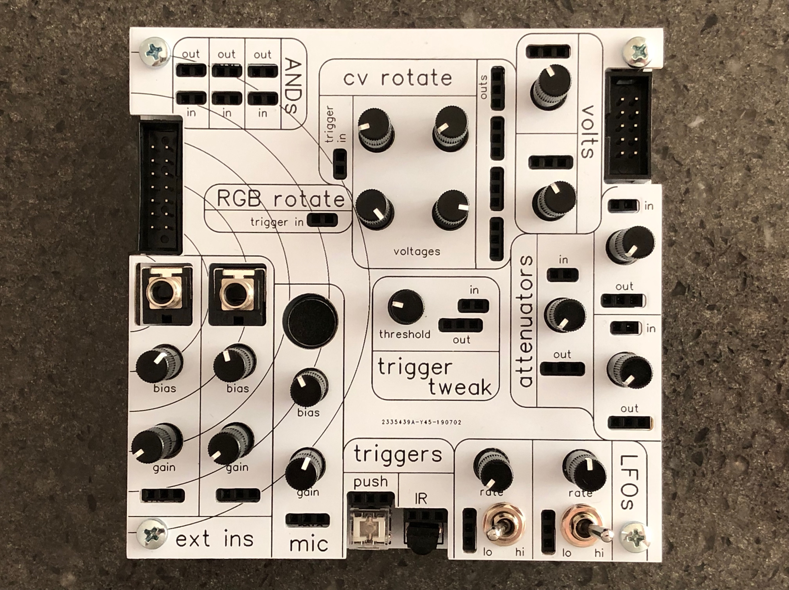

**Introduction:**

The ec500 is an expandable analog video synth system based on the ideas laid out by Jonas Bers in his CHA/V project. Briefly, the core concept is this: The VGA standard is readily hackable because it breaks out the six necessary components – red, green, blue, hsync, vsync, and ground – into separate pins. It’s also fairly forgiving of signals out of spec (although the ec500 tries to keep those to a minimum).

The CHA/V project takes advantage of this, and of the availability of cheapo ($5!) VGA tester boards. Jonas’s original concept involved soldering wires directly to the back of the tester board; subsequently he & various other contributors have developed various refinements & offshoots. The ec500 is our 508: Loop Detected offshoot/refinement/expansion of this concept. You can learn more at Jonas’s website: <https://jonasbers.com/chav/>

The ec500 i/o expander adds a number of new features to the error.core; it also depends on the error.core for power, so you will not be able to use it by itself. Among the features of the i/o expander are:

* Two line-level inputs with adjustable gain and DC offset
* An on-board microphone with adjustable gain and DC offset
* A lighted pushbutton switch
* An infrared receiver
* Two triangle-core LFOs with switchable range
* Three passive attenuators
* A comparator that is configured to condition triggers from other inputs, but which also has Other Uses
* A bunch of control voltage sources, some of which round-robin with suitable trigger input
* A triggerable round-robin for the main R, G, & B busses from the error.core
* Three AND logic gates

**Getting Started**

First, you’ll need to connect the components. There are two rectangular IDC box headers on the i/o expander, and each one is a different size, to help make it clear what goes where. When connecting the ribbon cables, be sure you’re using the correct cable for the various connectors – they should just fit into the plastic surround, with no extra pins visible. The i/o expander should be connected via the LEFT header, into the corresponding RIGHT header on the error.core.

The cable ends and the boxes have a ridge and a slot that will match up when you have things right-way-round. Don’t force them! Look for the ridge & make sure it’s lined up with the slot.

Here’s what the whole system looks like when hooked up:

If you were previously using the system without the i/o expander, you’ll need to remove the three jumpers before plugging the i/o expander the right-hand expansion header on the error.core:

Go ahead and plug it all in, and if everything looks right, power it on! There is an LED inside of the pushbutton on the i/o expander, so you should be able to tell if it’s working or not.

Now that you’re hooked up and powered on, let’s take a tour of the ec500 i/o expander.

**What is what**





P

O



N

M

L

K

J

H



G

F

E

D

C

B

A

**A: AND gates**

An AND gate takes two inputs (each of the 1x2 headers on the “in” side takes 2 separate inputs, one into each hole), compares them, and outputs a HIGH signal when both inputs are also HIGH. Feed two oscillators into one of the input blocks here, and the signal on the output will be a particular sort of combination of them.

**B: expansion header A**

This is where you connect the i/o expander to the ec500 error.core master module.

**C: RGB rotate**

The i/o expander is designed specifically to work with the error.core – on expansion bus A, there is a send and return from the R, G, & B mix buses on the error.core. The RGB rotate feature takes a trigger input, and when it receives a trigger, it round-robins the three buses (e.g. on first trigger received, the R input gets routed back to the G output, the G gets routed to the B, and the B to the R. And so on). If you’re not using it with a variable signal (such as the mic, or the LFO, or whatever), you might want to keep it connected to the pushbutton switch, as it occasionally picks up stray signal from the ether otherwise & acts kinda weird. Or maybe you want to encourage that!

**D: external line-level input jacks**

These are 3.5mm mono jacks suitable for bringing signal in from outside, including from a modular synth. They are DC coupled & are thus usable for both audio (or video) and CV/trigger signals.

**E: bias controls**

Each input channel, as well as the mic channel, has a bias control. Many audio and other A/C signals oscillate up & down from positive to negative, but VGA (and composite) video does its work in the range (roughly) from 0-1V. The bias controls add positive voltage to the incoming signal to get it fully up above zero, if that’s what you want.

**F: gain controls**

Each input channel is configurable from 1/10 to 10x amplification via these knobs. The mic channel is adjustable from unity up to 100x gain.

**G: electret microphone capsule**

This seemed like the easiest way to get external audio into the ec500 system, for use as a trigger or CV source, for people who want to do video synth stuff while they (or someone else) are makng music.

**H: lighted pushbutton switch**

The output from this can be used as a trigger for either the RGB rotate or the CV rotate (or both).

**J: CV rotate**

Four knobs, four outputs, one trigger input. Each knob is connected to one output, and a trigger input received at the trigger in jack rotates which knob is connected to which output. The rotation goes clockwise around the four knobs, IIRC.

**K: expansion header B**

With a reasonably robust power supply, it will be possible to daisy-chain additional future ec500 modules off of this header.

**L: volts**

Sometimes you just want a manually controllable control voltage source for use with one of the CV-controllable oscillators. That’s what these are for.

**M: attenuators**

Passive attenuators – the input is just connected to the output through the pot which is configured as a voltage divider. Use them for additional attenuation of input signals, or use them for more nuanced mixing along with the R,G, or B mix bus on the error.core.

**N: trigger tweak**

This is my favorite feature of the i/o expander. It’s a comparator with a controllable threshold voltage (controlled by the knob), meaning you can take a variable or spiky signal (such as the mic output, or one of the line-ins, or one of the LFOs, or whatever) and use it to generate a trigger output whenever it goes above a certain threshold. VERY handy if, say, you’re performing in a room with music & you want to have something change in your video patch when only the loudest sound (e.g. the kick drum) happens. BUT this feature also has a secret identity! Plug an oscillator in to the input, and what will be output will be a signal that tracks the input perfectly, but is narrower (depending on where you set the threshold). Split one oscillator between one of the color buses and the trigger tweak input. Take the trigger tweak output to another color bus, and you’ll see that second color either fringing the edge of the original, or nearly covering it, depending on the threshold setting.

**O: LFOs**

LFO = low-frequency oscillator. These are (more or less) triangle-wave LFOs, and are switchable between fairly slow (one cycle takes multiple seconds) and fairly fast (fast enough that they can be used as video-rate oscillators. They aren’t syncable like the oscillators on the error.core, so at high speeds they’ll roll, although a careful hand on the rate control can get them pretty still, at least for a minute or two. So: use them as a CV source, use them to generate triggers (thru the trigger tweak) for things, or patch them directly into one of the color buses.

**P: IR receiver**

I originally designed this system for a multi-monitor installation, and I wanted some audience interactivity. So I set up this IR receiver to basically emit a trigger anytime it receives any infrared signal. You can leave basically any IR remote lying around, and pushing any button on it will generate a trigger. Connected to the RGB rotate, pushing buttons on the remote will rotate the RGB, which feels a lot like channel surfing. It’s a simple effect, but actually kinda fun. It also sometimes triggers when lights are turned off & on, or when you’re taking a photo with your smartphone (with infrared autofocus).

-- Ross Grady, July 16, 2019